7.1.2 Editors - 3D View - Tool Shelf - Mesh - Edit Mode
Detailed table of content 1
Tool Shelf - Mesh - Edit Mode 7
Extrude Region tools group 7
Inset 12
Bevel 14
Loop Cut tools group 16
Knife Tool Group 18
Poly Build 20
Spin Tools Group 22
Smooth / Randomize Tools group 24
Edge and Vertex Slide Tools Group 25
Shrink/Fatten / Push/Pull Tools Group 27
Shear and To Sphere Tools Group 28
To Sphere 30
Rip Tools Group 30

Detailed table of content
Detailed table of content
Detailed table of content 1
Tool Shelf - Mesh - Edit Mode 7
Extrude Region tools group 7
Snapping 7
Precision movement 7
Header Values 7
Move without Widget 8
Limit Axis 8
Extrude Region 8
Tool Settings 8
Axis Type 8
Last Operator Extrude Region and Move 9
Flip Normals 9
Move X, Y Z 9
Orientation 9
Proportional editing 9
Proportional Falloff 9
Proportional Size 9
Connected 9
Projected(2D) 9
Extrude Region 9
Header Value 10
Tool Settings 10
Offset Even 10
Last Operator Extrude Region and Shrink/Fatten 10
Flip Normals 10
Offset 10
Offset Even 10
Proportional editing 10
Proportional Falloff 10
Proportional Size 10
Connected 10
Projected(2D) 10
Extrude Individual 10
Header Value 11
Last Operator Extrude Individual Faces and Move 11
Offset 11
Offset Even 11
Proportional editing 11
Proportional Falloff 11
Proportional Size 11
Connected 11
Projected(2D) 11
Extrude to cursor 11
Tool Settings 11
Rotate Source 11
Last Operator Move 12
Move X Y Z 12
Orientation 12
Proportional editing 12
Proportional Falloff 12
Proportional Size 12
Connected 12
Projected(2D) 12
Inset 12
Tool Settings 12
Outset 12
Interpolate 12
Offset Even 13
Offset Relative 13
Last Operator Inset Faces 13
Boundary 13
Offset Even 13
Offset Relative 13
Edge Rail 13
Thickness 13
Depth 13
Outset 13
Select Outer 13
Individual 13
Interpolate 14
Bevel 14
Tool Settings 14
Width type 14
Segments 14
Profile 14
Vertex only 14
Last Operator Bevel 14
Width type 14
Width 14
Segments 14
Profile 14
Vertex only 14
Clamp Overlap 15
Loop Slide 15
Mark Seams 15
Mark Sharp 15
Material 15
Harden Normals 15
Face Strength Mode 15
None 15
New 15
Affected 15
All 15
Outer Miter 15
Sharp 16
Patch 16
Arc 16
Inner Miter 16
Sharp 16
Arc 16
Spread 16
Loop Cut tools group 16
Loop Cut and Slide 17
Tool Settings 17
Number of Cuts 17
Correct UV's 17
Last Operator Loop Cut and Slide 17
Number of Cuts 17
Smoothness 17
Falloff 17
Factor 17
Even 17
Flipped 17
Clamp 18
Correct UV's 18
Offset Edge Loop Cut 18
Last Operator Offset Edge Slide 18
Cap Endpoint 18
Edge Slide Factor 18
Even 18
Flipped 18
Clamp 18
Correct UV's 18
Knife Tool Group 18
Knife tool 18
Hotkey functionality in the footer text 19
Tool Settings 19
Occlude Geometry 19
Only Selected 19
Bisect 19
Tool Settings 20
Fill 20
Clear Inner 20
Clear Outer 20
Axis threshold 20
Last Operator Bisect 20
Plane Point X , Y , Z 20
Plane Normal X , Y , Z 20
Fill 20
Clear Inner 20
Clear Outer 20
Axis threshold 20
Poly Build 20
Usage: 20
Tool Settings 21
Create Quads 21
Last Operator 21
Extrude At Cursor Move panel 21
Flip Normals 21
Move X, Y Z 21
Orientation 21
Face at Cursor Move panel 21
Move X, Y Z 21
Orientation 22
Proportional editing 22
Proportional Falloff 22
Proportional Size 22
Connected 22
Projected(2D) 22
Spin Tools Group 22
Spin 22
Usage 22
Tool Settings 23
Steps 23
Axis 23
Last Operator Spin 23
Steps 23
Duplicate 23
Angle 23
Center X Y Z 23
Axis X Y Z 23
Spin Duplicate 23
Smooth / Randomize Tools group 24
Smooth 24
Usage 24
Tool Settings 24
Repeat 24
Last Operator Smooth Vertices 24
Smoothing 24
Repeat 24
X Axis, Y Axis, Z Axis 24
Randomize 24
Usage 24
Tool Settings 24
Uniform 24
Normal 24
Random Seed 24
Last Operator Smooth Vertices 25
Amount 25
Uniform 25
Normal 25
Random Seed 25
Edge and Vertex Slide Tools Group 25
Edge Slide 25
Header Values 25
Tool Settings 25
Correct UV's 25
Last Operator Edge Slide 25
Factor 25
Even 26
Flipped 26
Clamp 26
Correct UV's 26
Vertex Slide 26
Header Values 26
Tool Settings 26
Correct UV's 26
Last Operator Vertex Slide 26
Factor 26
Even 26
Flipped 26
Clamp 27
Correct UV's 27
Shrink/Fatten / Push/Pull Tools Group 27
Shrink / Fatten 27
Header Values 27
Tool Settings 27
Offset Even 27
Last Operator Shrink/Fatten 27
Offset 27
Offset Even 27
Proportional editing 27
Proportional Falloff 27
Proportional Size 27
Connected 27
Projected(2D) 28
Push/Pull 28
Header Values 28
Last Operator Push/Pull 28
Distance 28
Proportional editing 28
Proportional Falloff 28
Proportional Size 28
Connected 28
Projected(2D) 28
Shear and To Sphere Tools Group 28
Shear 28
Tool Settings 29
Orientation 29
Last Operator Shear 29
Offset 29
Axis 29
Axis Ortho 29
Orientation 29
Proportional editing 29
Proportional Falloff 29
Proportional Size 29
Connected 29
Projected(2D) 29
To Sphere 30
Usage 30
Last Operator To Sphere Panel 30
Factor 30
Proportional editing 30
Proportional Falloff 30
Proportional Size 30
Connected 30
Projected(2D) 30
Rip Tools Group 30
Rip Vertices 31
Tool Settings 31
Fill 31
Last Operator Rip 31
Move X , Y , Z 31
Constraint Axis 31
Orientation 31
Proportional editing 31
Proportional Falloff 31
Proportional Size 31
Connected 31
Projected(2D) 32
Extend Vertices 32
Last Operator Extend Vertices 32
Move X , Y , Z 32
Constraint Axis 32
Orientation 32
Proportional editing 32
Proportional Falloff 32
Proportional Size 32
Connected 32
Projected(2D) 32

Tool Shelf - Mesh - Edit Mode
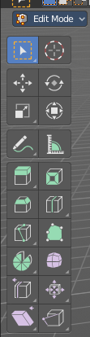
In Edit mode with a mesh object you will find some polygon tools in the tool shelf.

Select, 3D Cursor, Transform, Annotate and Measure

The select and transform tools and the annotation and measure tool is already described in the chapter Object Mode. So we won't cover it here again. And start directly with the polygon tools.

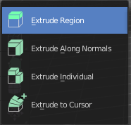
Extrude Region tools group
This group contains some extrude tools. A few more exotic ones can be found in the mesh menu.
There are some general settings, since they all have some move settings We will cover them all here for all of the tools.

Snapping
Holding down Ctrl activates temporary global snapping.

Precision movement
When you hold down shift, then you will have a much slower but also much preciser movement.

Header Values
When you move your object then you will see some values in the header, which defines the current position of the object.
The value m stands for the default metric system. Meters. You can change the units in the Properties editor in the Scene properties in the Units panel. When you choose kilometers here then you will see a km instead m.
The value D stands for the distance of the current selected axis. This can also be two axis. Then you have two d values. The value in the brackets is then the direct distance to the starting point.
These values are always relative to the starting point. You always start with zero, regardless of the real world position.

Move without Widget
You don't have to use the widget to move the object. You can also click aside of it, and drag the object around. The mouse turns into a move cursor. The standard behaviour then is to move in screen space. When you want to move into a specific axis, then press X or Y or Z to limit the movement to this axis.

Limit Axis
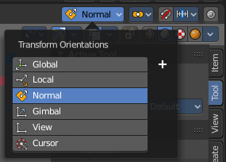
When you want to move along a specific axis, then press X or Y or Z to limit the movement to this axis. You usually start in global orientation. But you can change this in the Orientation settings.
By holding down the mouse button and pressing the X, Y or Z key twice you can toggle this to local. But also to other orientations. This depends in what orientation you start. With normal you can toggle that way between Normal and Global.

Extrude Region
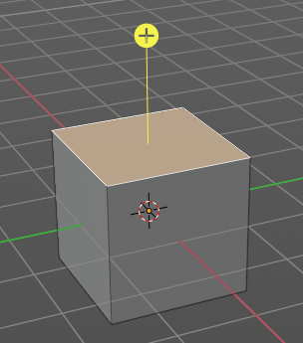
The Extrude Region tool extrudes by default along the vertex normals of the current selection. When it's more than one vertex, edge or face, then the middle will be used.
The method works the same in all Mesh select modes. Vertice, Edge and Face Mode.
When you activate the tool, then you will by default see a yellow widget at the selection. Drag it to extrude the selection.

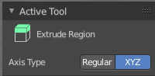
Tool Settings

Axis Type
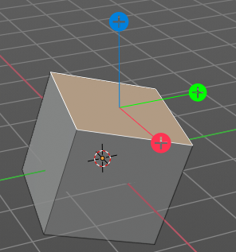
You can choose between the regular axis type. That's the yellow widget with just one handler. It always points in the direction of the middled normals of the selection.
Or you can use the XYZ axis type. That's a handler with three axis. This widget can be aligned with the transform orientation methods.

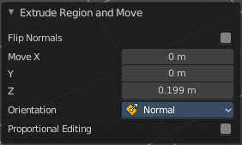
Last Operator Extrude Region and Move

Flip Normals
Flips the normals of the extruded faces.

Move X, Y Z
The position. Attention, the actual world orientation and rotation does not matter here. It always starts with a value of zero, and moves relative to this zero then. For the actual location values have a look in the sidebar in the transform panel.


Orientation
The widget can have different orientations. The menu items should be self explaining.


Proportional editing
Enables proportional editing. Activating proportional editing reveals further settings.

Proportional Falloff
Here you can adjust the falloff methods.

Proportional Size
Here you can see and adjust the falloff radius.

Connected
The proportional falloff gets calculated for connected parts only.

Projected(2D)
The proportional falloff gets calculated in the screen space. Depth doesn't play a role. When it's in the radius, then it gets calculated.

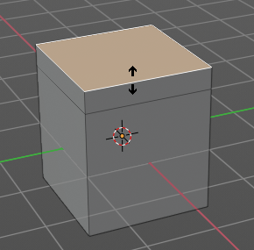
Extrude Region
Extrudes the selection along local normals. You won't see a widget here. Simply drag.
The method works the same in all Mesh select modes. Vertice, Edge and Face Mode.

Header Value
This tool works like a shrink fatten extrude. And so you will see a corresponding set of values in the header.

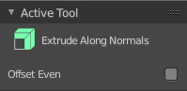
Tool Settings

Offset Even
Scales the offset to give more even thickness. Without this checked the farer away faces will have a bigger extrude amount.

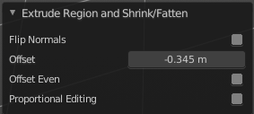
Last Operator Extrude Region and Shrink/Fatten

Flip Normals
Flips the normals of the extruded faces.

Offset
The current extrude amount.

Offset Even
Scales the offset to give more even thickness. Without this checked the farer away faces will have a bigger extrude amount.

Proportional editing
Enables proportional editing. Activating proportional editing reveals further settings.

Proportional Falloff
Here you can adjust the falloff methods.

Proportional Size
Here you can see and adjust the falloff radius.

Connected
The proportional falloff gets calculated for connected parts only.

Projected(2D)
The proportional falloff gets calculated in the screen space. Depth doesn't play a role. When it's in the radius, then it gets calculated.

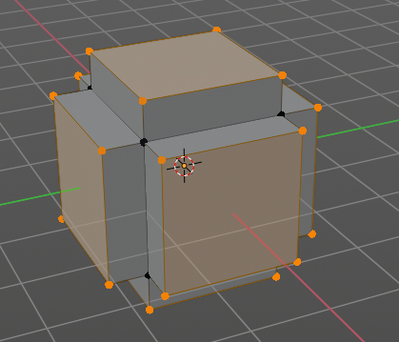
Extrude Individual
Extrudes the selection along local normals of each individual face. You won't see a widget here. Simply drag.
The method works the same in all Mesh select modes. Vertice, Edge and Face Mode.

Header Value
This tool works like a shrink fatten extrude. And so you will see a corresponding set of values in the header.

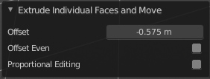
Last Operator Extrude Individual Faces and Move

Offset
The current extrude amount.

Offset Even
Scales the offset to give more even thickness. Without this checked the farer away faces will have a bigger extrude amount.

Proportional editing
Enables proportional editing. Activating proportional editing reveals further settings.

Proportional Falloff
Here you can adjust the falloff methods.

Proportional Size
Here you can see and adjust the falloff radius.

Connected
The proportional falloff gets calculated for connected parts only.

Projected(2D)
The proportional falloff gets calculated in the screen space. Depth doesn't play a role. When it's in the radius, then it gets calculated.

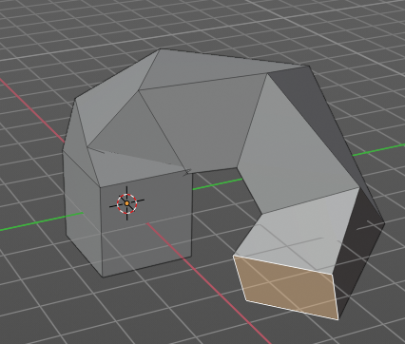
Extrude to cursor
Extrudes the selection towards the mouse cursor by clicking and dragging The extruded geometry will rotate towards the mouse pointer.

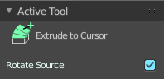
Tool Settings

Rotate Source
In theory this setting should rotate the source geometry too to achieve a better result. In practice this setting does nothing.

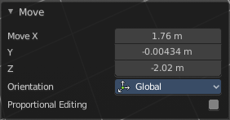
Last Operator Move

Move X Y Z
The current extrude amount.

Orientation
The widget can have different orientations. The menu items should be self explaining.

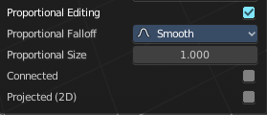
Proportional editing
Enables proportional editing. Activating proportional editing reveals further settings.

Proportional Falloff
Here you can adjust the falloff methods.

Proportional Size
Here you can see and adjust the falloff radius.

Connected
The proportional falloff gets calculated for connected parts only.

Projected(2D)
The proportional falloff gets calculated in the screen space. Depth doesn't play a role. When it's in the radius, then it gets calculated.

Inset
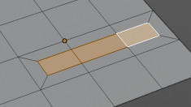
Inset insets edges into the selected faces. Think of it as a extrude inwards the face.
Activate the tool, drag the mouse. But carefully. The control is not the best. You better adjust the amount in the last operator.

Tool Settings

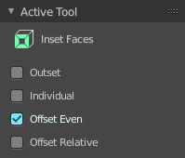
Outset
With outset ticked the Inset will not extrude inwards but outwards.

Interpolate
Blend Face Data across the inset.

Offset Even
Scales the offset to give more even thickness.

Offset Relative
Scales the offset by surrounding geometry.

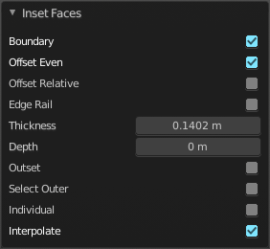
Last Operator Inset Faces

Boundary
With Boundary ticked you will get the connect edges in the corners. Without the edges ends straight.
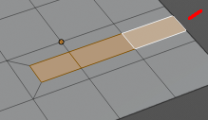

Offset Even
Scales the offset to give more even thickness.

Offset Relative
Scales the offset by surrounding geometry.

Edge Rail
Inset the region along existing edges.

Thickness
Thickness adjusts the thickness of the inset geometry.

Depth
With depth you can bevel the inset geometry. It is then not longer coplanar to the initial face.

Outset
With outset ticked the Inset will not extrude inwards but outwards.

Select Outer
With Select Outer the outer ring will be selected after the Inset.

Individual
Inset every face individually.

Interpolate
Blend Face Data across the inset.

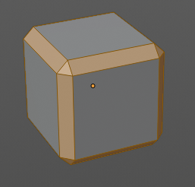
Bevel
The Bevel Tool adds a bevel to the selected geometry.
Usage: first select the geometry that you want to bevel. Then activate the tool. Don't wonder that the mouse movement does nothing. That's by design. Adjust the amount in the Last Operator Bevel panel.

Tool Settings

Width type
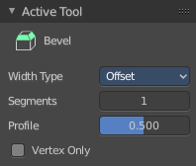
Here you can choose the Amount type for the bevel action.

Segments
How many segments gets created.

Profile
Controls the Profile shape. 0.5 means round.

Vertex only
Bevel Vertices only.

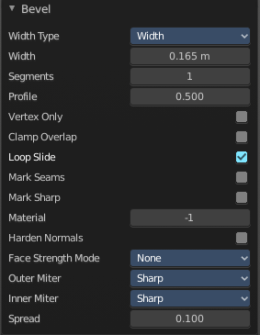
Last Operator Bevel

Width type
Here you can choose the Amount type for the bevel action.

Width
The Bevel amount

Segments
How many segments gets created

Profile
Controls the Profile shape. 0.5 means round.

Vertex only
Bevel Vertices only.

Clamp Overlap
Do not allow bevelled geometry to overlap each other.

Loop Slide
Prefer slide along edge to even widths.

Mark Seams
Mark the edges of the new created geometry as seams.

Mark Sharp
Mark the edges of the new created geometry sharp.

Material
Material for bevelled faces. -1 is the surrounding material.

Harden Normals
When enabled, the per-vertex face normals of the bevel faces are adjusted to match the surrounding faces, and the normals of the surrounding faces are not affected. This will keep the surrounding faces flat (if they were before), with the bevel faces shading smoothly into them. For this effect to work, custom split normals need to be enabled, which requires Auto Smooth to be enabled (see Normals). As a convenience, that option will be enabled for you if it is not already when you enable Harden Normals here.

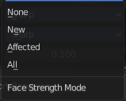
Face Strength Mode
Set Face Strength on the faces involved in the bevel, according to the specified mode. This can be used in conjunction with a Weight Normals Modifier (with the Face Influence option checked).

None
Do not set face strength.

New
Set the face strength of new faces along edges to Medium, and the face strength of new faces at vertices to Weak.

Affected
In addition to those set for the New case, also set the faces adjacent to new faces to have strength Strong.

All
In addition to those set for the Affected option, also set all the rest of the faces of the model to have strength Strong.

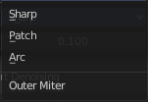
Outer Miter
How the outer miter is set. Miter is how the bevel rounding at a corner is done.


Sharp
Creates a sharp miter.

Patch

This replaces the outside vertex of a miter with 3 vertices. And uses a patch pattern there.

Arc

This replaces the vertex of a miter with 2 vertices, joined by an arc. A separate Spread parameter says how far to move the vertices away from their original position.

Inner Miter
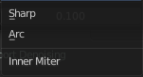
How the inner miter is set. Miter is how the bevel rounding at a corner is done.

Sharp
Creates a sharp miter.

Arc
This replaces the vertex of a miter with 2 vertices, joined by an arc. A separate Spread parameter says how far to move the vertices away from their original position.

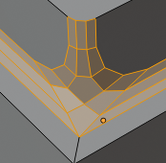
Spread
Belongs to inner miter method Arc. Here you can adjust how strong the inner radius is bent.

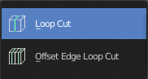
Loop Cut tools group

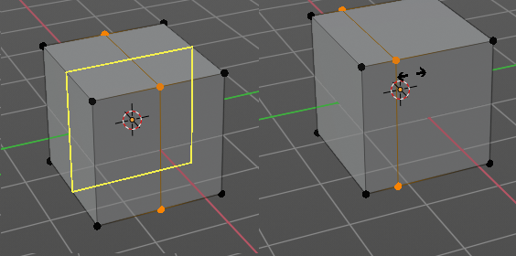
Loop Cut and Slide
Loop Cut and Slide adds edge loops. When you hover with the mouse over the geometry then you will see a yellow line in the exact middle of the face(s). This is what will be the new cutted edge.
When you click once, then this edge gets created. When you click and hold, then you can move this edge to a new location.
Loop cut ignores selections. It will try to divide the face under the mouse, and continue the loop until it is closed, or until it cannot continue. At poles for example.

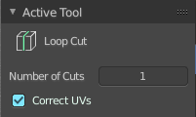
Tool Settings

Number of Cuts
You can with one cut add more than one edge. Here you can adjust the amount.
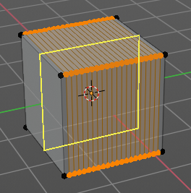
Note that here you need to adjust this setting before adding the loop. Note also that the yellow preview line will not show all added loops. But just the yellow line.
The settings remains its values as long as you don't close Bforartists and restart it.

Correct UV's
Correct the UV's when transforming the new added loop.

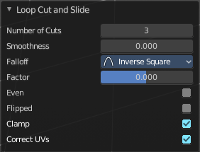
Last Operator Loop Cut and Slide
Note that all settings here just changes the latest added loop. Not all added loops in the current session.

Number of Cuts
The number of cuts that gets added. It can be more than one loop at once.

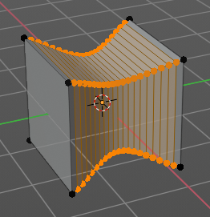
Smoothness
This value defines how smooth the loop cut gets added. From flat to bent.

Falloff
Here you can adjust the Falloff type for smoothness.

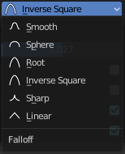
Factor
Here you can change the center of the added loop.

Even
Make the edge loop match the shape of the adjacent edge loop

Flipped
When Even mode is active, flips between the two adjacent edge loops.

Clamp
Clamp within the edge extend.

Correct UV's
Corrects the UV's when modifying the geometry.

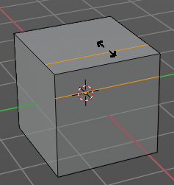
Offset Edge Loop Cut
Slides the selected edge(s)
Usage: select the edges that you want to slide. Click to confirm.
You can adjust the sliding amount in the Last Operator Offset Edge Slide.

Last Operator Offset Edge Slide

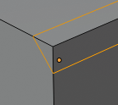
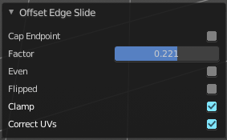
Cap Endpoint
Cap Endpoint caps the loose edges.

Edge Slide Factor
Here you can adjust the slide amount.

Even
Make the edge loop match the shape of the adjacent edge loop

Flipped
When Even mode is active, flips between the two adjacent edge loops.

Clamp
Clamp within the edge extend.

Correct UV's
Corrects the UV's when modifying the geometry.

Knife Tool Group

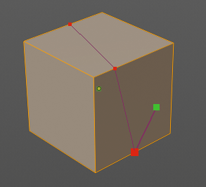
Knife tool
The Knife tool cuts the geometry, and adds edges. When it crosses existing geometry then it adds a vertice at the crossing point.
Useage: activate the tool, left click to define the starting point. This can also be a point in the middle of a face. But ideally you choose an existing vertice or an edge as the start and endpoints. The knife tool tries to snap to them when you get close with the mouse cursor.
When done press Enter or Spacebar to confirm. Right click abandons the operation.
When you create a vertice in the middle of a face, then the knife tool will try to connect this vertice by an existing vertice of this face when you confirm with spacebar.

Hotkey functionality in the footer text
Have a look at the footer when you work with this tool. Here you will find further instructions and hotkeys.
Enter, Pad Enter, Spacebar - confirm
Esc key, RMB - cancel the operation
LMB start the cut
Double LMB - close the cut
E - create new cut
Ctrl or Shift while dragging - Snap to the middle of an edge
Z - cut through the whole geometry, also the backfaces.
MMB - pan the view.
Alt MMB - rotate the view.

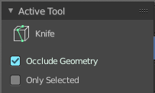
Tool Settings

Occlude Geometry
Just cut the visible geometry that points towards you. Not the backfaces.

Only Selected
Just cut through selected geometry. Not through not selected.

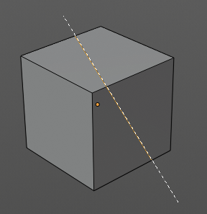
Bisect
Bisect cuts geometry along a plane. This description is a bit misleading though. You simply cut through the whole geometry by defining a line. And the cut goes through the geometry from the current view.

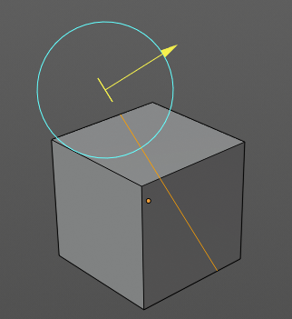
When you have set your cut and release the mouse then you reveal a widget with which you can move and rotate the cut. Clicking at the arrow and drag moves the cut. Clicking at the circle and drag rotates the cut.

Tool Settings

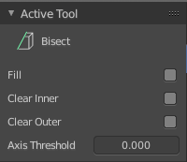
Fill
Fills the cut.

Clear Inner
Removes the inner part of the face to cut.

Clear Outer
Removes the outer part of the face to cut.

Axis threshold
Axis threshold.

Last Operator Bisect

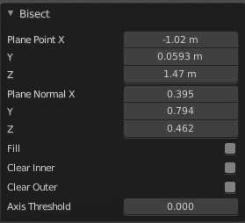
Plane Point X , Y , Z
Defines the start point of the Bisect cut.

Plane Normal X , Y , Z
The direction in which the bisect points.

Fill
Fills the cut.

Clear Inner
Removes the inner part of the face to cut.

Clear Outer
Removes the outer part of the face to cut.

Axis threshold
Axis threshold.

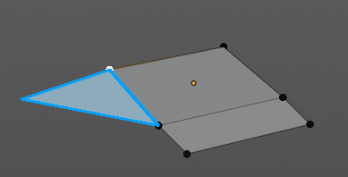
Poly Build
This tool extrudes out edges and faces from the border of existing open geometry.
The tool will not work at a cube, since here it cannot extrude out an existing polygon from a border. There is no border since the geometry is closed.

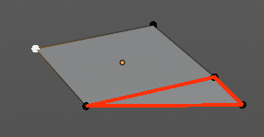
Usage:
Move the mouse over an edge until it turns blue. Then you can left click and drag to extrude it out.
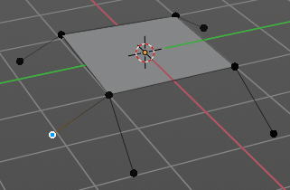
Holding ctrl and clicking will extrude the last selected element to the mouse cursor. To extrude out an edge from a vertice don't click with left mouse. This would create a polygon. But with right mouse button.
Holding down shift allows you to mark vertices, edges or polygons that you want to remove. By clicking the selected geometry will be deleted.
You can just work at one edge at a time.

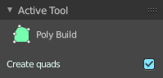
Tool Settings

Create Quads
Create quad or tri geometry.

Last Operator
We have two last operators here, dependant of which method we use. Dragging out edges will reveal the Extrude At Cursor Move panel. Holding down CTRL will reveal the Face at Cursor Move panel.

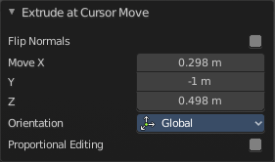
Extrude At Cursor Move panel

Flip Normals
Flips the normals of the extruded faces.

Move X, Y Z
The position of the new created element. Attention, the actual world orientation and rotation does not matter here. It always starts with a value of zero, and moves relative to this zero then. For the actual location values have a look in the sidebar in the transform panel.

Orientation
The widget can have different orientations. The menu items should be self explaining.

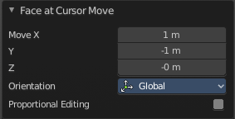

Face at Cursor Move panel

Move X, Y Z
The position of the new created element. Attention, the actual world orientation and rotation does not matter here. It always starts with a value of zero, and moves relative to this zero then. For the actual location values have a look in the sidebar in the transform panel.

Orientation
The widget can have different orientations. The menu items should be self explaining.

Proportional editing
Enables proportional editing. Activating proportional editing reveals further settings.

Proportional Falloff
Here you can adjust the falloff methods.

Proportional Size
Here you can see and adjust the falloff radius.

Connected
The proportional falloff gets calculated for connected parts only.

Projected(2D)
The proportional falloff gets calculated in the screen space. Depth doesn't play a role. When it's in the radius, then it gets calculated.

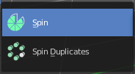
Spin Tools Group

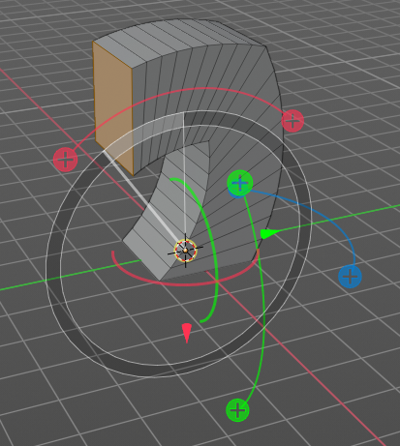
Spin
The Spin tool extrudes the selection and spins it by a defined amount and segments. This amount and number of segments can be adjusted.
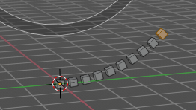
When you activate the tool then you reveal some widgets with various handlers.
You can spin vertices, edges and faces. And even whole closed objects.

Usage
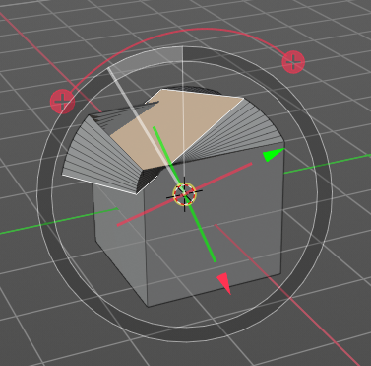
Select the geomertry that you want to spin out. In our case we choose a face at a cube.
The first thing that you need to is to activate the correct Axis widget, which can be done in the Tool Settings. The ones with the big + buttons at the end defines in which direction the extrusion happens. And when you touch them then you start the spin extrusion. The rest of the widget functionality should be self explaining. You have handlers to pull and to rotate.
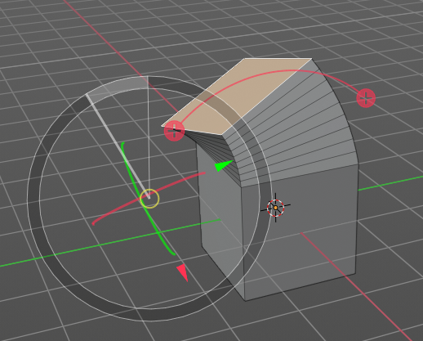
Hint, you activate all three axis widgets by holding down shift, and clicking at the axis buttons in the tool settings.
The second step is then to move the center of the spin to the desired location to get the rotation that you want. This can be done by the move handler. Or you click into the middle of the widget, at the white circle there, and drag it around.
For an accurate rotation around a single axis you should work in one of the orthographic views.

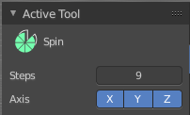
Tool Settings

Steps
The number of divisions.

Axis
Activates the axis handler to perform the spin operation.
Hint, you activate all three axis widgets by holding down shift, and clicking at the axis buttons in the tool settings.

Last Operator Spin

Steps
Steps is the number of segments.

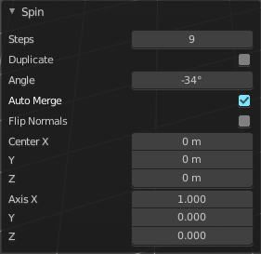
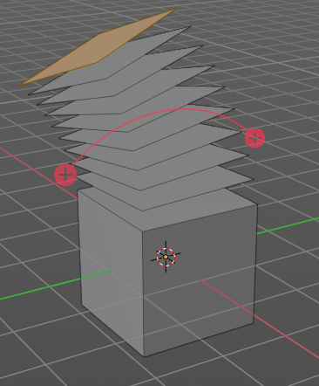
Duplicate
With duplicate checked the geometry gets duplicated instead of extruded.

Angle
Angle defines the angle of the spin.

Center X Y Z
The Centre edit boxes defines the centre of the radius for the spin operation. In our example the X value is set to 2, and the Z value is set to 1.

Axis X Y Z
Axis defines the extrude direction. With X and Z values you can twist the result.

Spin Duplicate
Spin Duplicate is the exact same tool than Spin. It uses the same operator under the hood, and has no extra functionality. Not even the checkbox for duplicate is checked in the identical Adjust Last Operation Panel.
I think that this tool is meant to create duplicates by default. Simply use the Spin tool, and in the last operator panel tick Duplicate.

Smooth / Randomize Tools group

Smooth
Smoothens the selected vertices.

Usage
Activate the tool, move the mouse.

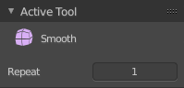
Tool Settings

Repeat
How often the smoothing should be applied.

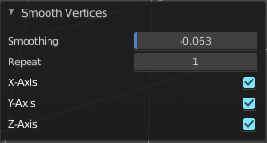
Last Operator Smooth Vertices

Smoothing
The smoothing factor.

Repeat
How often the smoothing should be applied.

X Axis, Y Axis, Z Axis
Which axis to affect

Randomize
Randomizes the selected vertices.

Usage
Activate the tool, move the mouse.

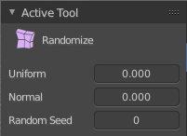
Tool Settings

Uniform
Uniform offset. The higher the value the more uniform the offset becomes.

Normal
Align the random offset to the normals. This is a factor. 0 means no offset but completely random vertices positions. 1 means completely aligned with the normal axis, and just along this normal axis.

Random Seed
The seed for the randomization.

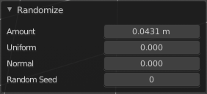
Last Operator Smooth Vertices

Amount
The randomization amount.

Uniform
Uniform offset. The higher the value the more uniform the offset for all vertices becomes.

Normal
Align the random offset to the normals. This is a factor. 0 means no offset but completely random vertices positions. 1 means completely aligned with the normal axis, and just along this normal axis.

Random Seed
The seed for the randomization.

Edge and Vertex Slide Tools Group

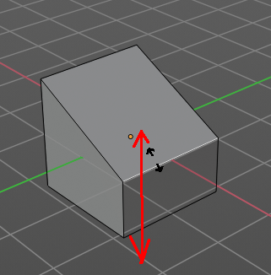
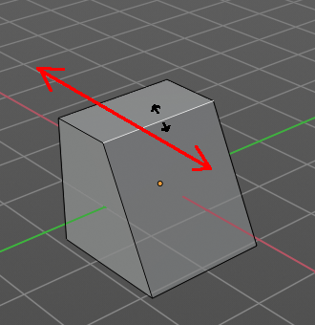
Edge Slide
Edge Slide slides the selected edge along the face that it is part of. This is for the edge at a cube into two possible directions.
This tool requires to have at least one edge selected.

Header Values
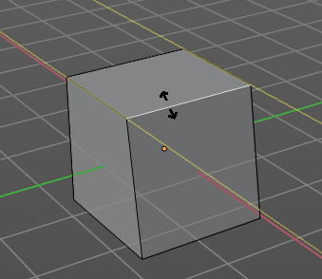
The header values shows you the current transformation. But also hints towards a hotkey.
Holding down ALT will allow you to slide the edges behind the limits of the guide edge. Yellow infinite guide lines appears.

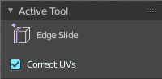
Tool Settings

Correct UV's
Correct UV's corrects the UV's while editing the geometry.

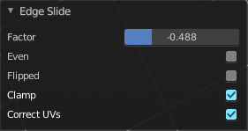
Last Operator Edge Slide

Factor
Factor is a sliding box Here you can adjust the slide strength numerically. The width of the face is the 0-1 range.

Even
Make the Edge loop match the shape of the adjacent edge loop.

Flipped
When Even Mode is active, flips between the two adjacent edge loops.

Clamp
Clamp within the edge extend.

Correct UV's
Correct UV's corrects the UV's while editing the geometry.

Vertex Slide
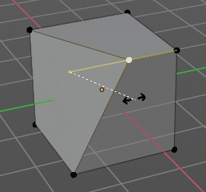
Vertex Slide slides the selected vertice along the edge that it is part of. This is for the corner vertice at a cube into three possible directions.

Header Values
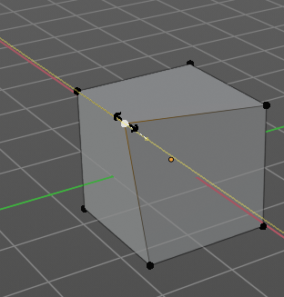
The header values shows you the current transformation. But also hints towards a hotkey.
Holding down ALT will allow you to slide the edges behind the limits of the guide edge. Yellow infinite guide lines appears.

Tool Settings

Correct UV's
Correct UV's corrects the UV's while editing the geometry.

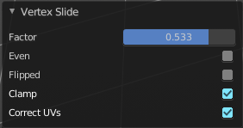
Last Operator Vertex Slide

Factor
Factor is a sliding box Here you can adjust the slide strength numerically. The width of the face is the 0-1 range.

Even
Make the Edge loop match the shape of the adjacent edge loop.

Flipped
When Even Mode is active, flips between the two adjacent edge loops.

Clamp
Clamp within the edge extend.

Correct UV's
Correct UV's corrects the UV's while editing the geometry.

Shrink/Fatten / Push/Pull Tools Group

Shrink / Fatten
Shrink / Fatten shrinks or fattens the selection. The faces moves along the normals of the faces.

Header Values
The header values shows you the current transformation. But also hints towards a hotkey. Holding down ALT will turn off Even Thickness.

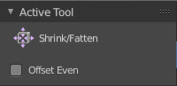
Tool Settings

Offset Even
Scales the offset to give more even thickness. Without this checked the farer away faces will have a bigger extrude amount.

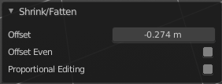
Last Operator Shrink/Fatten

Offset
The offset amount

Offset Even
Scales the offset to give more even thickness. Without this checked the farer away faces will have a bigger extrude amount.

Proportional editing
Enables proportional editing. Activating proportional editing reveals further settings.

Proportional Falloff
Here you can adjust the falloff methods.

Proportional Size
Here you can see and adjust the falloff radius.

Connected
The proportional falloff gets calculated for connected parts only.

Projected(2D)
The proportional falloff gets calculated in the screen space. Depth doesn't play a role. When it's in the radius, then it gets calculated.

Push/Pull
It pushes or pulls the selection relative to the center of the selection.

Header Values
The header values shows you the current transformation.

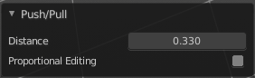
Last Operator Push/Pull

Distance
The push pull amount

Proportional editing
Enables proportional editing. Activating proportional editing reveals further settings.

Proportional Falloff
Here you can adjust the falloff methods.

Proportional Size
Here you can see and adjust the falloff radius.

Connected
The proportional falloff gets calculated for connected parts only.

Projected(2D)
The proportional falloff gets calculated in the screen space. Depth doesn't play a role. When it's in the radius, then it gets calculated.

Shear and To Sphere Tools Group

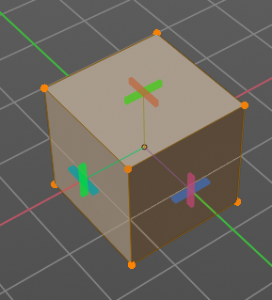
Shear
Shear shears the selection. When you activate the tool then you will reveal a widget. This widget allows you to shear the selection in all possible axis.

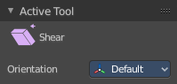
Tool Settings


Orientation
Here you can choose the orientation for the shear action.

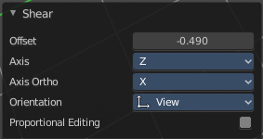
Last Operator Shear

Offset
Here you can adjust an offset.

Axis
Defines one axis of the imaginary shear axis plane.

Axis Ortho
Defines the other axis of the imaginary shear axis plane.

Orientation
Here you can choose the orientation for the shear action.

Proportional editing
Enables proportional editing. Activating proportional editing reveals further settings.

Proportional Falloff
Here you can adjust the falloff methods.

Proportional Size
Here you can see and adjust the falloff radius.

Connected
The proportional falloff gets calculated for connected parts only.

Projected(2D)
The proportional falloff gets calculated in the screen space. Depth doesn't play a role. When it's in the radius, then it gets calculated.

To Sphere
Shapes a selection of objects into the shape of a sphere. The calculation happens with the object origins.
In Object mode this tools requires to have more than one object selected.

Usage

Select the vertices, activate the tool, then drag the mouse in the 3D viewport. In the header you will read the current factor then. Which tells you how close you are towards the sphere shape.



Last Operator To Sphere Panel

Factor
The factor to transform the selection into a shape form.

Proportional editing
Enables proportional editing. Activating proportional editing reveals further settings.

Proportional Falloff
Here you can adjust the falloff methods.

Proportional Size
Here you can see and adjust the falloff radius.

Connected
The proportional falloff gets calculated for connected parts only.

Projected(2D)
The proportional falloff gets calculated in the screen space. Depth doesn't play a role. When it's in the radius, then it gets calculated.

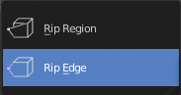
Rip Tools Group

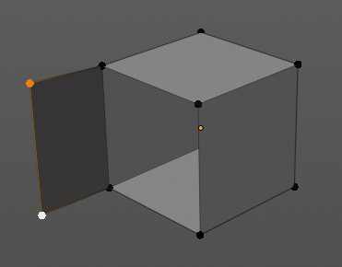
Rip Vertices
Rip splits the edges between the selected vertices. It creates two edges out of one.
This tool works similar to the Edge Split tool. It also selects the outer edges so that you immediately move them. Right click will snap them back to the initial space.

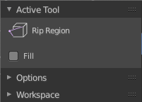
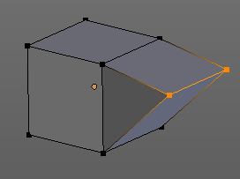
Tool Settings

Fill
Fills the gap between the new edges when you move the geometry.

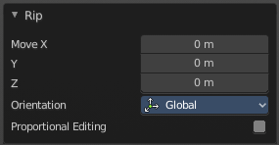
Last Operator Rip

Move X , Y , Z
Here you can adjust the position.

Constraint Axis
Here you can limit the position relative to the source object.

Orientation
Orientation is a drop-down box where you can choose the type of orientation for the mirroring action.

Proportional editing
Enables proportional editing. Activating proportional editing reveals further settings.

Proportional Falloff
Here you can adjust the falloff methods.

Proportional Size
Here you can see and adjust the falloff radius.

Connected
The proportional falloff gets calculated for connected parts only.

Projected(2D)
The proportional falloff gets calculated in the screen space. Depth doesn't play a role. When it's in the radius, then it gets calculated.

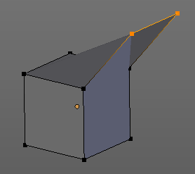
Extend Vertices
Extend vertices extrudes out the selected vertices. When you do this operation at an edge then you will create N-Gons that way.

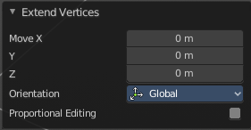
Last Operator Extend Vertices

Move X , Y , Z
Here you can adjust the position.

Constraint Axis
Here you can limit the position relative to the source object.

Orientation
Orientation is a drop-down box where you can choose the type of orientation for the mirroring action.

Proportional editing
Enables proportional editing. Activating proportional editing reveals further settings.

Proportional Falloff
Here you can adjust the falloff methods.

Proportional Size
Here you can see and adjust the falloff radius.

Connected
The proportional falloff gets calculated for connected parts only.

Projected(2D)
The proportional falloff gets calculated in the screen space. Depth doesn't play a role. When it's in the radius, then it gets calculated.

